

**American International University-Bangladesh (AIUB)**  
 Department of Computer Science

Faculty of Science & Technology (FST)

**Project Title: Health Navigation Management System Section: P**

**Group: 08**

**SUBMITTED TO: MD ABDULLAH ALL MAHMUD**

**WRITTEN BY : RAKIBUL ISLAM AKASH**

**Semester: Fall 25-26**

|  |  |  |
| --- | --- | --- |
| ***Group:*** | | ***Section:*** |
| **SL** | **Student Name** | **Student ID** |
| 1 | 1. Rakibul Islam Akash | 23-50363-1 |
| 2 | 2. Md Rakib Hossain | 23-50379-1 |
| 3 | 3. Riana Ramzan | 23-50383-1 |
| 4 | 4. Md Ahanaf Tajware Abir | 22-49718-3 |

Table of Contents

1. Project Proposal xx

1.1 Background to the Problem xx

1.2 Selection of Process Model xx

2. Software Requirements Specification (SRS) / PRD xx

2.1 Scopes and Features xx

2.2 User Story Table xx

2.3 Requirements Traceability Matrix xx

2.3.1 Functional Requirements xx

2.3.2 Non-Functional Requirements xx

3. Software Design xx

3.1 System Deisgn xx

3.2 UI Deisgn using Figma xx

4. Git Workflow xx

5. Software Testing xx

6. Conclusion xx

**1. PROJECT PROPOSAL**



* 1. **Background to the Problem**

The use of information and communication technology has changed the way healthcare services are delivered across the world. Despite these advancements, many healthcare systems—especially in developing regions, still face serious challenges. Medical services are often scattered and poorly connected, making it difficult for patients to find the right doctors, choose reliable diagnostic laboratories, manage prescriptions, or keep track of medical reports and test samples. As a result, patients experience delays in treatment, higher medical costs, and unnecessary stress.

The **Health Navigation Management System (HNMS)** is designed to reduce these problems by bringing patients, hospitals (doctors), pathology laboratories, and administrators onto a single digital platform. The main goal of the system is to make healthcare services easier to access and manage by improving communication and coordination among all stakeholders involved in patient care.

From the **patient’s point of view**, HNMS provides a simple and secure way to register, log in, book appointments, upload prescriptions, and store medical reports. Patients can receive suggested medical tests based on uploaded prescriptions, choose suitable laboratories according to location, price, and ratings, and schedule appointments with doctors or labs both online and offline. By keeping all medical records in one place, the system helps patients maintain their health history without relying on physical documents.

From the **hospital and doctor’s perspective**, the system helps manage appointments, review patient reports, and provide medical evaluations more efficiently. Doctors can be listed under hospitals with specific specialties and availability schedules, allowing patients to find appropriate medical professionals easily. This digital process reduces administrative workload and supports better clinical decision-making.

From the **pathology laboratory perspective**, HNMS enables test booking, sample tracking, and report delivery through a structured system. Patients can track the status of their test samples in real time and receive digital copies of reports before collecting physical copies. This improves transparency and reduces uncertainty during the diagnostic process.

The **administrator** plays an important role in maintaining the system. Through a centralized dashboard, administrators can manage users, hospitals, labs, feedback, and service listings while monitoring overall system activity. This helps ensure service quality, data security, and smooth operation of the platform.

Additionally, HNMS includes features such as doctor recommendations, lab selection options, pharmacy suggestions, and health rating with future risk assessment. By analyzing past medical records, test results, and doctor evaluations, the system can provide approximate health insights and preventive recommendations. These features encourage early awareness and healthier lifestyle choices.

In conclusion, the Health Navigation Management System aims to simplify healthcare navigation by connecting patients, healthcare providers, and diagnostic services through a single, integrated platform. By improving accessibility, coordination, and record management, the system seeks to enhance the overall quality and efficiency of healthcare services.

* 1. **Selection of Process Model**

**Software Development Model Used: Incremental Development Model**

**Justification for Using the Incremental Development Model**

The **Incremental Development Model** has been selected for the **Health Navigation Management System (HNMS)** because the system is **large-scale, modular, and safety-critical**, involving multiple stakeholders such as **patients, doctors, diagnostic laboratories, pharmacies, and system administrators**. This model enables structured growth of the system while maintaining reliability, flexibility, and quality—key requirements for healthcare software.

Each module can be **designed, implemented, tested, and deployed as separate increment**. The Incremental Model supports this modular architecture by allowing controlled development and delivery of individual system components without waiting for full system completion.

**Early Delivery of Working Software**

One of the primary advantages of the Incremental Model is **early availability of functional software**. In HNMS:

* Core features such as **user login, appointment booking, and report storage** can be delivered in early increments.
* Advanced features such as **AI-based test recommendations, health analytics, and risk scoring** can be added in later stages.

This approach allows **early user validation**, stakeholder feedback, and real-world testing, which improves system usability and reduces the risk of late-stage design failures.

**Risk Reduction in Healthcare Applications**

Healthcare systems demand **high reliability, data accuracy, and patient safety**. The Incremental Model reduces development risk by:

* Testing each increment independently before integration
* Identifying defects early in the development lifecycle
* Preventing large-scale failures caused by unresolved design issues

By validating each functional increment separately, the model ensures that **critical healthcare operations remain stable and secure**.

**Flexibility to Handle Changing Requirements**

Healthcare software is highly sensitive to **frequent requirement changes**, such as:

* Regulatory and compliance updates
* New healthcare policies or standards
* Feedback from patients, doctors, and administrators
* Future feature expansion (e.g., pharmacy integration, paid diagnostic services)

The Incremental Model allows **controlled modifications and feature additions** without affecting already deployed system components, making it ideal for evolving healthcare environments.

**Improved Testing, Quality Assurance, and Maintenance**

Each development increment undergoes:

* Unit testing
* Integration testing
* User acceptance testing (UAT)

This step-by-step testing process ensures **higher software quality, better maintainability, and easier debugging**. Since healthcare applications require continuous availability and minimal downtime, incremental updates simplify long-term maintenance and system upgrades.

**Conclusion**

The Incremental Development Model is the most suitable choice for the Health Navigation Management System because it:

* Enables early and continuous delivery of working features
* Minimizes risks associated with healthcare software
* Accommodation evolving requirements and regulations
* Ensures rigorous testing and high system reliability

Therefore, the Incremental Model provides a **balanced, safe, and efficient development approach** that aligns perfectly with the technical, operational, and regulatory demands of a healthcare management system.

## 2. SOFTWARE REQUIREMENTS SPECIFICATIONS (SRS) / PRODUCT REQUIREMENTS DOCUMENT (PRD)

**2.1 Scopes and Features**

The Health Navigation and Management System (HNMS) is a web-based healthcare management platform that supports five user roles: Patient, Hospital, Pathology Laboratory, Pharmacy, and Admin. The system focuses on secure authentication, profile management, laboratory test booking, dashboard monitoring, and role-based navigation.

**Project Scope**

**In Scope**

The system shall provide:

* Multi-role signup and login
* OTP based password recovery
* Role-based dashboards
* Profile viewing and editing
* Secure password change
* Patient lab test booking
* Laboratory test management visibility through dashboard
* Role-based menu navigation
* Session based logout security

**Out of Scope**

The system will not handle:

* Emergency services
* Physical medicine delivery
* Surgical or hospital treatment operations

**Core Laboratory Focus**

The laboratory role in HNMS focuses on:

* Viewing incoming test bookings
* Monitoring sample status through dashboard
* Managing completed and pending lab reports
* Uploading diagnostic reports

**2.2 User Story Table**

| ID | User Role | User Story | Priority |
| --- | --- | --- | --- |
| US01 | New User | I want to sign up by selecting my role so I can access system services. | High |
| US02 | User | I want to sign in using my credentials to access my dashboard. | High |
| US03 | User | I want to recover my password using OTP verification. | High |
| US04 | Patient | I want to book a lab test with preferred lab, date, and time. | High |
| US05 | Lab | I want to view and manage lab test requests from patients. | High |
| US06 | All Users | I want to view my profile information. | Medium |
| US07 | All Users | I want to edit my profile with proper validation. | Medium |
| US08 | All Users | I want to change my password securely. | Medium |
| US09 | All Users | I want to logout to protect my account. | High |
| US10 | Admin | I want to manage and verify system users. | High |
| US11 | All Users | I want to use menu navigation to access system pages. | Medium |

**2.3 Requirements Traceability Matrix**

| **Req ID** | **Requirement Description** | **Category** | **User Story** |
| --- | --- | --- | --- |
| FR01 | System shall allow role-based signup. | Functional | US01 |
| FR02 | System shall authenticate users during login. | Functional | US02 |
| FR03 | System shall allow OTP based password recovery. | Functional | US03 |
| FR04 | System shall allow patients to book lab tests. | Functional | US04 |
| FR05 | System shall allow labs to view booked tests. | Functional | US05 |
| FR06 | System shall allow users to view and edit profile. | Functional | US06, US07 |
| FR07 | System shall allow secure password change. | Functional | US08 |
| FR08 | System shall destroy session on logout. | Functional | US09 |
| FR09 | System shall allow admin to manage users. | Functional | US10 |
| NFR01 | Password must be minimum 8 characters. | Non-Functional | US01, US08 |
| NFR02 | Mandatory fields cannot be null. | Non-Functional | US07 |

**2.3.1 Functional Requirements**

**Authentication**

* The system shall support Patient, Hospital, Lab, Pharmacy, and Admin roles.
* Email must be unique and valid.
* Password must be minimum 8 characters.
* User must select a role during signup.
* On successful signup, user shall be redirected to dashboard.

**Signin**

* User shall login using email or mobile and password.
* System shall validate credentials with database.

**Forgot Password**

* System shall send OTP to registered email or mobile.
* User shall reset password after OTP verification.

**Laboratory Module**

* Patient shall book lab tests with preferred lab, date, and time.
* Laboratory user shall view test requests on dashboard.
* Laboratory shall track sample status.
* Laboratory shall upload completed reports.

**Dashboard**

* System shall show role-based dashboard information.
* Laboratory dashboard shall show pending, in-progress, and completed tests.

**Profile Management**

* User shall view profile.
* User shall edit profile with validation.

**Change Password**

* Current password must match database.
* New password must follow rules.
* Confirm password must match.

**Logout**

* System shall destroy session on logout.

**2.3.2 Non-Functional Requirements**

**Security**

* Passwords shall be stored in encrypted format.
* OTP shall expire after limited time.
* Sessions shall be destroyed on logout.

**Data Validation**

* Email must follow standard format.
* Phone number must be exactly 11 digits.
* Age must be minimum 15 years for patients.

**Performance**

* Dashboard data shall load within acceptable response time.  
  (I cannot verify exact seconds from PRD, so not stated numerically.)

**Usability**

* Interface shall be responsive.
* Menu navigation shall be user friendly.

# 3. SOFTWARE DESIGN

**3.1 System Design:** Draw the system design for your project using **Draw.io** or **LucidChart**.

**Use Case Diagram**

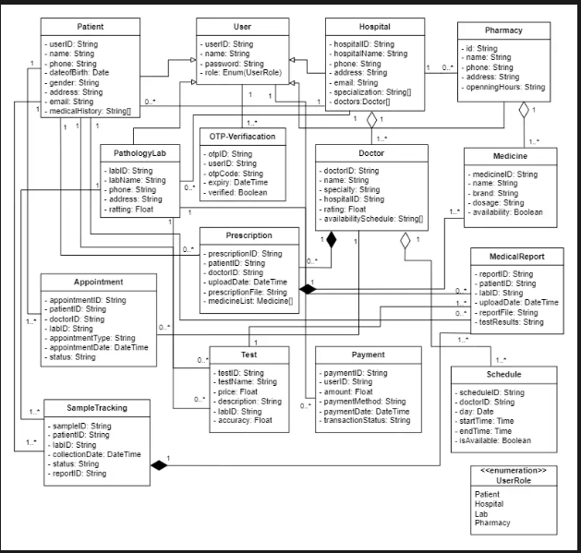**Class Diagram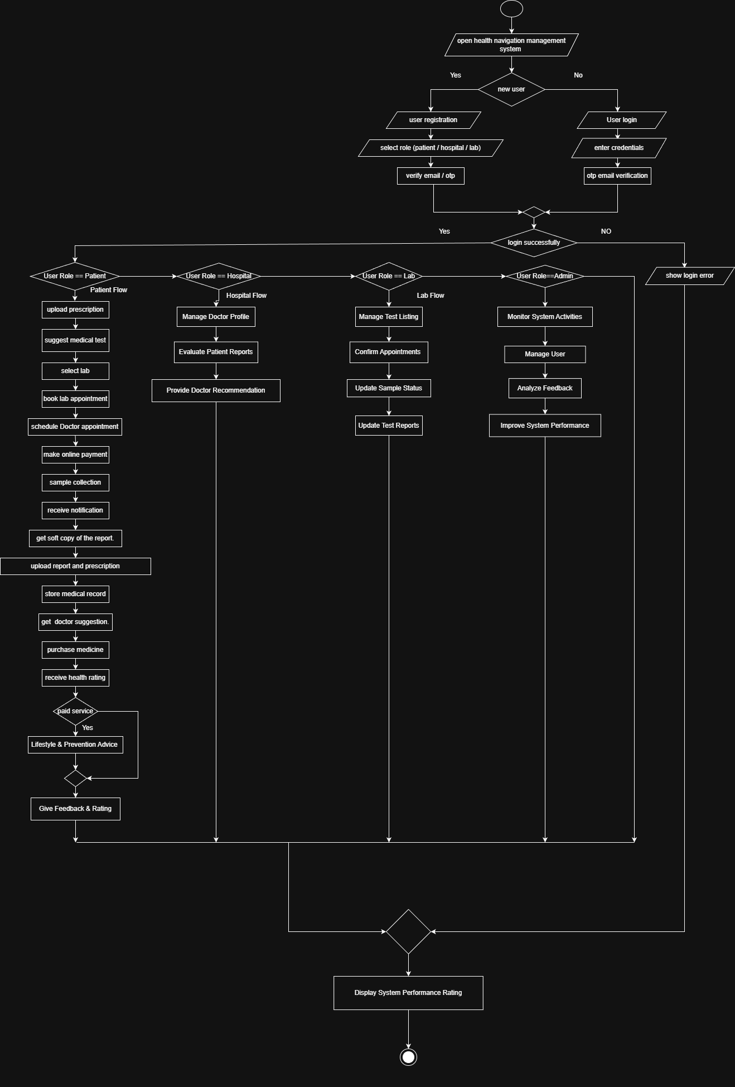Activity Diagram**

## UI/Wireframe design using Figma:

**Welcome**

**Patient Login:**

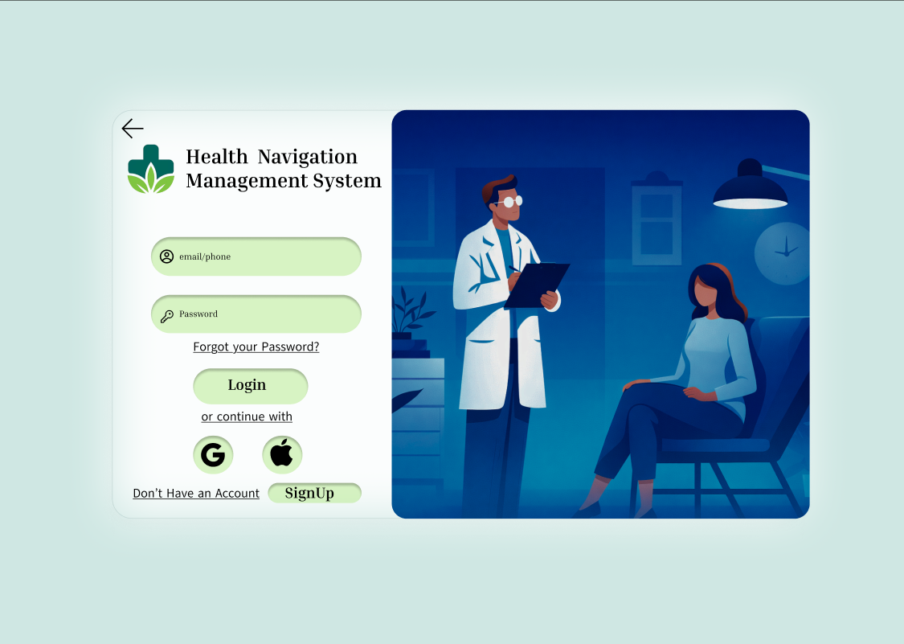

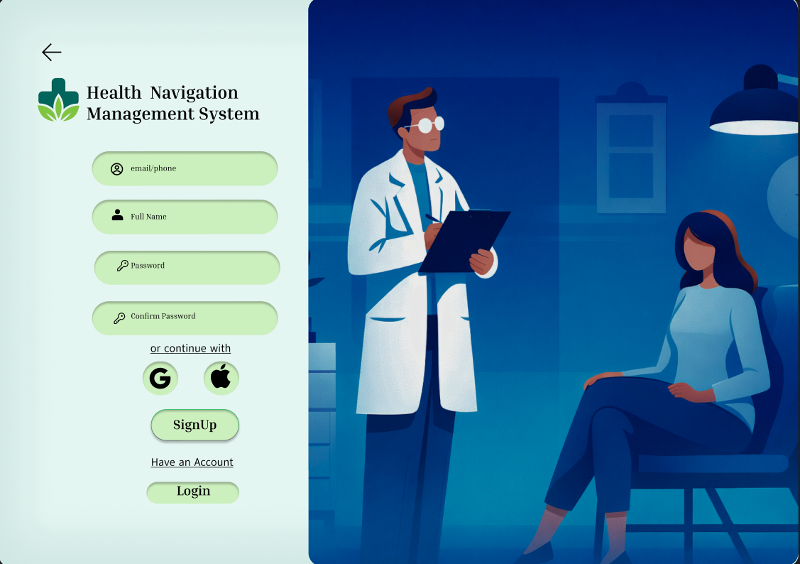**Patient Signup:**

**Patient Dashboard**

# 

**Forget Password**

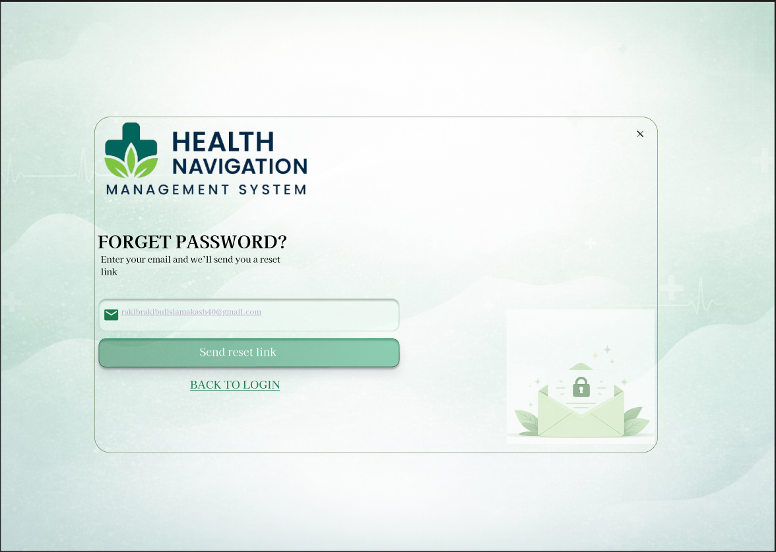

**Available Doctors:  
  
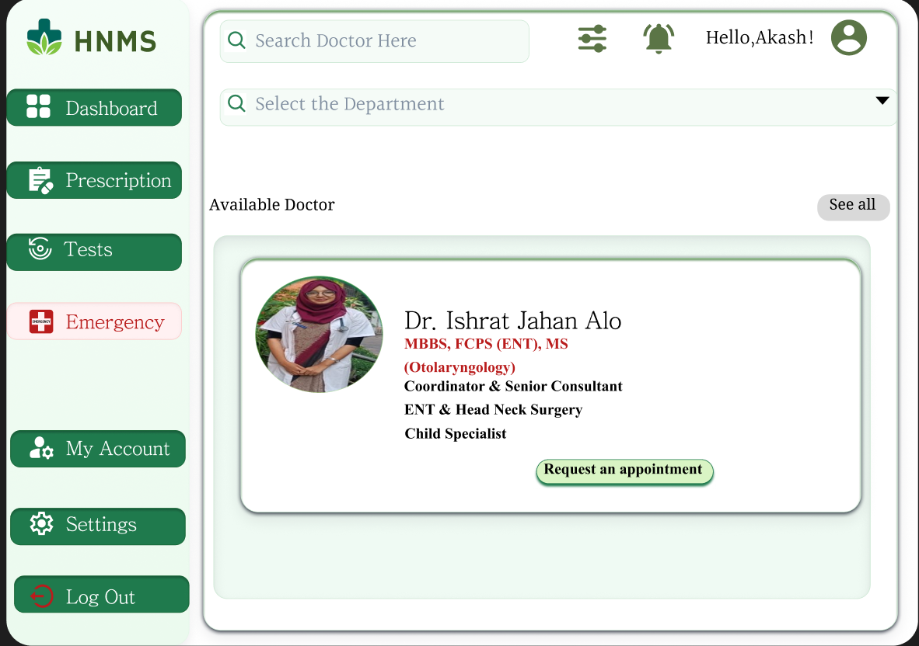**

**Available Hospital  
  
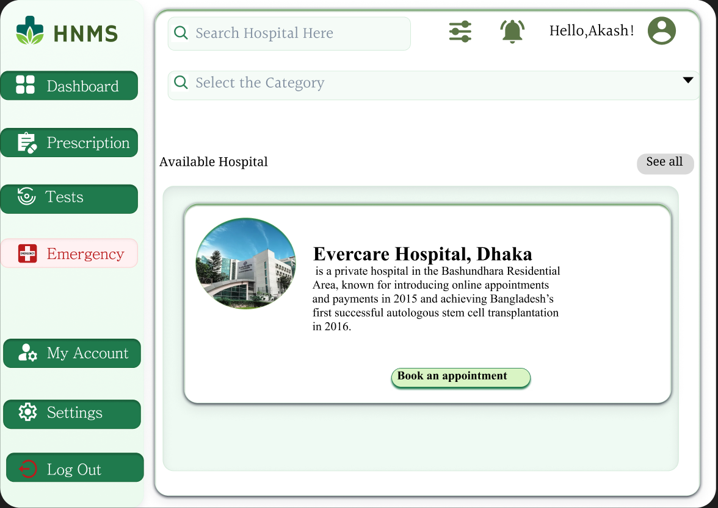**

**My Account  
  
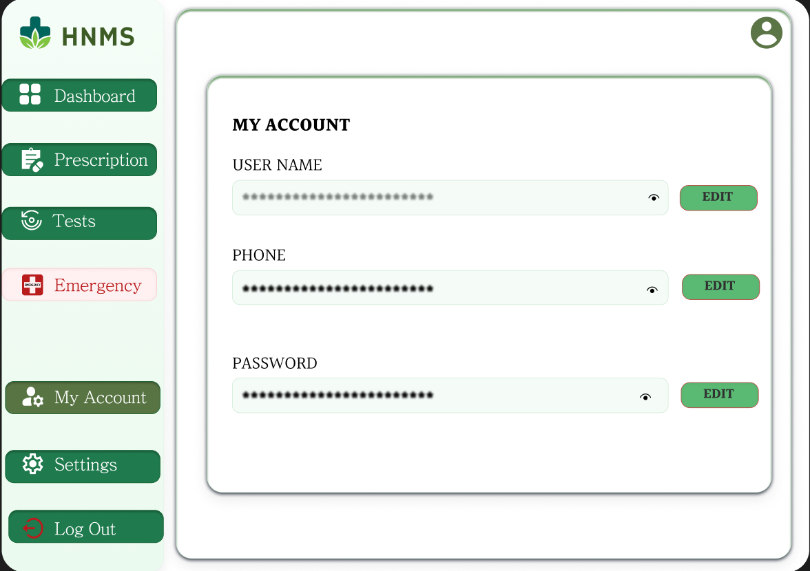**

**Settings  
  
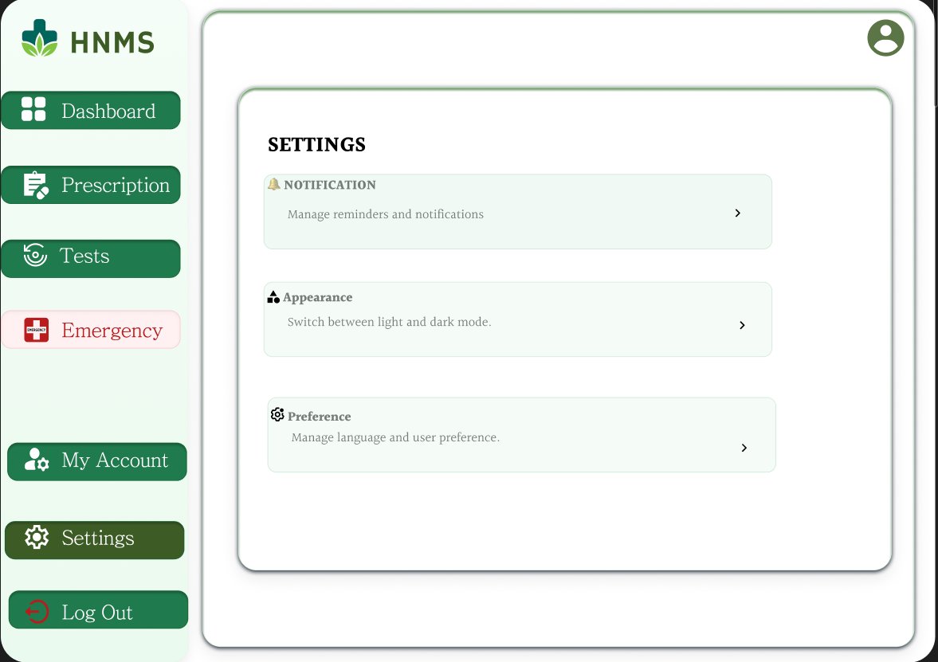**

**Admin Login  
  
  
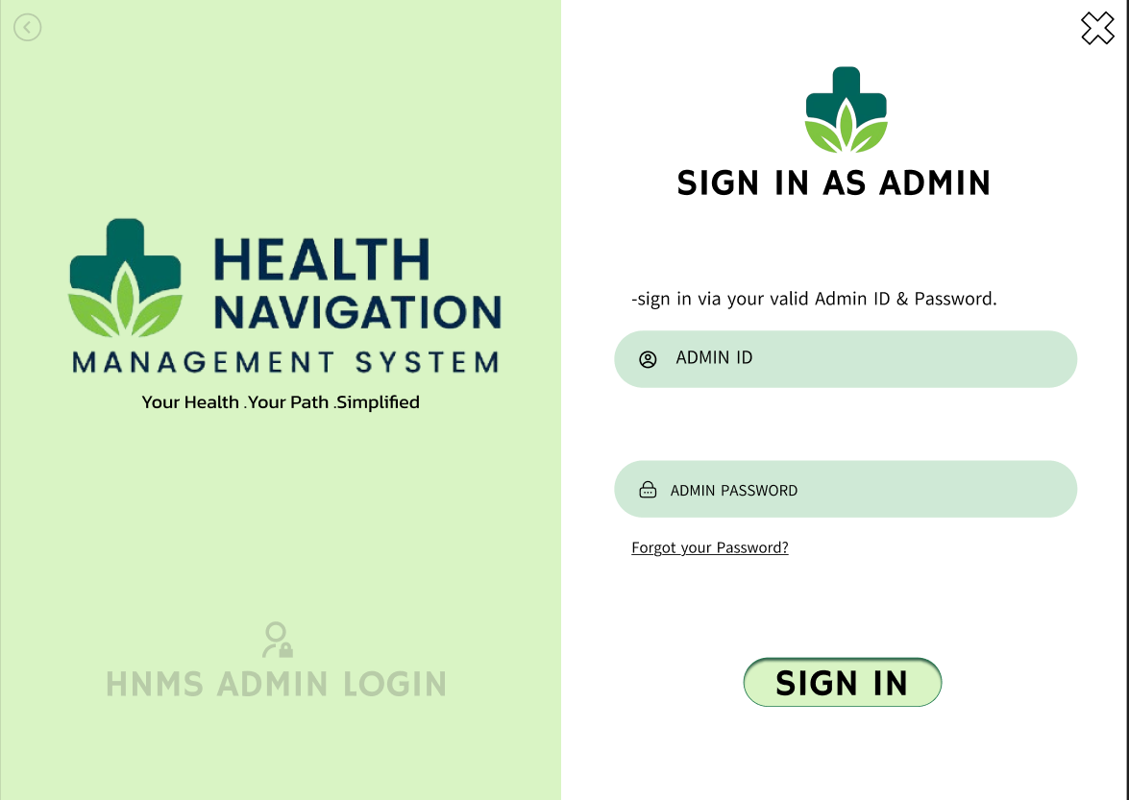**

**Admin Dashboard**

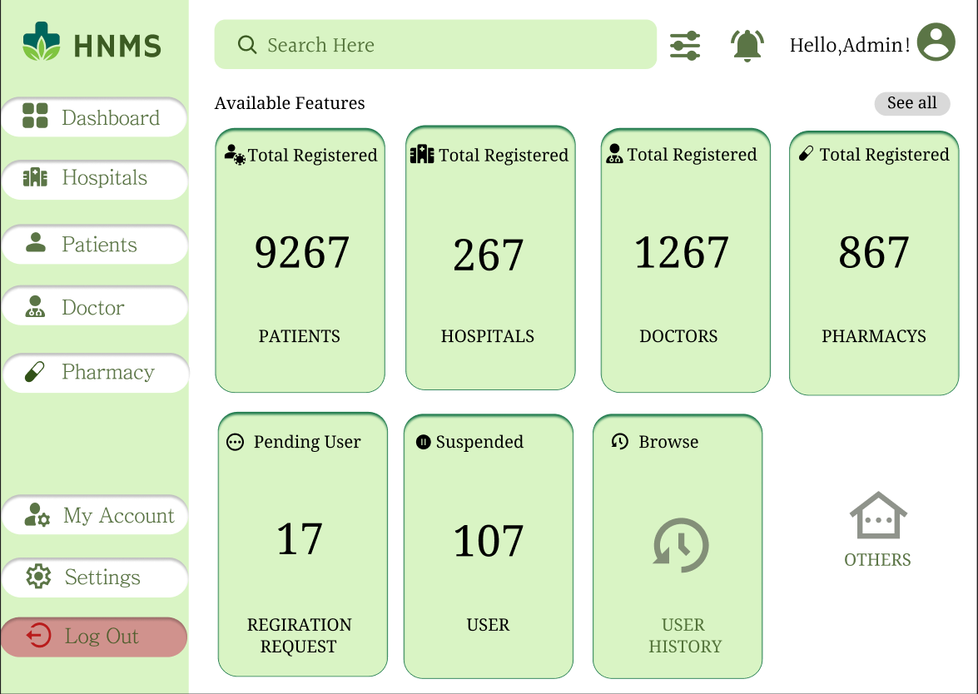

**Dr Login**

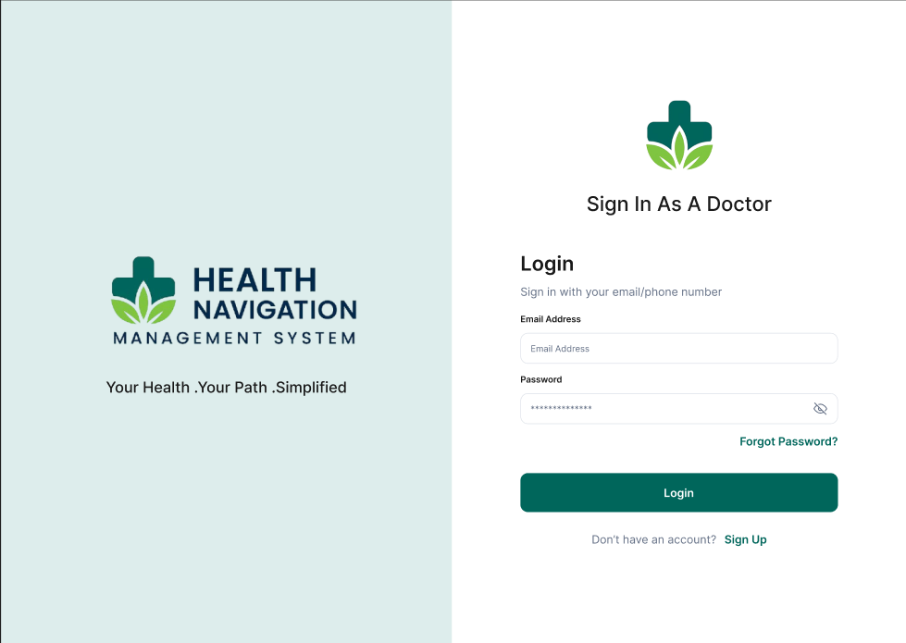

**Dr Forget Password**

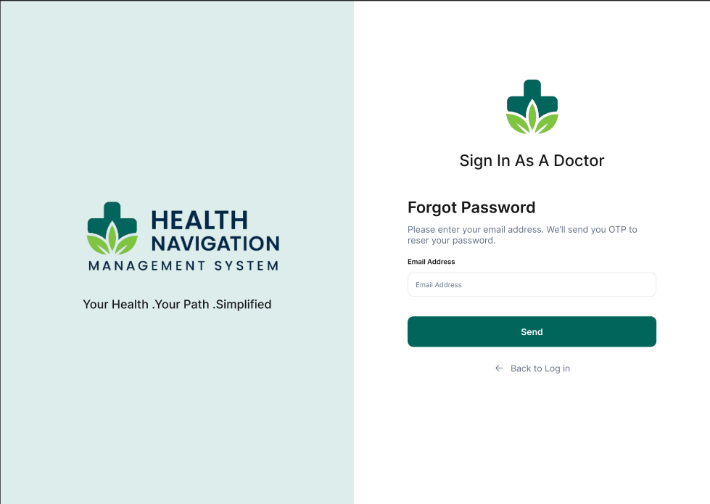

**Password Reset  
  
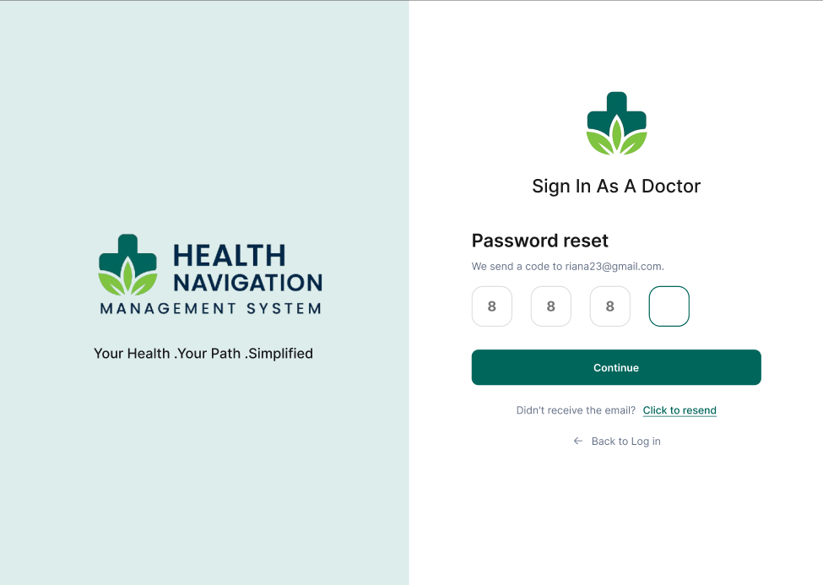**

**Dr Signup**

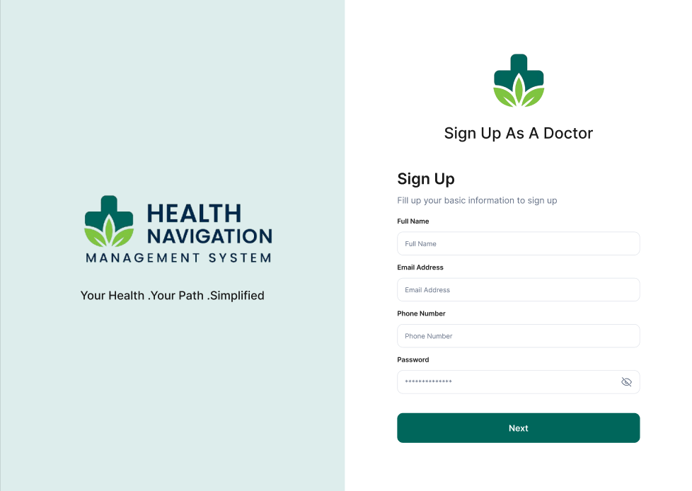

**Dr Signup**

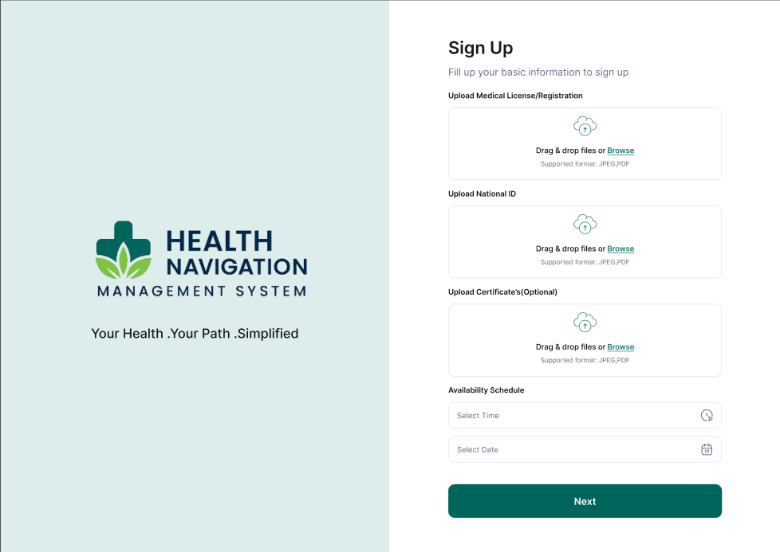

**Dr Signup**

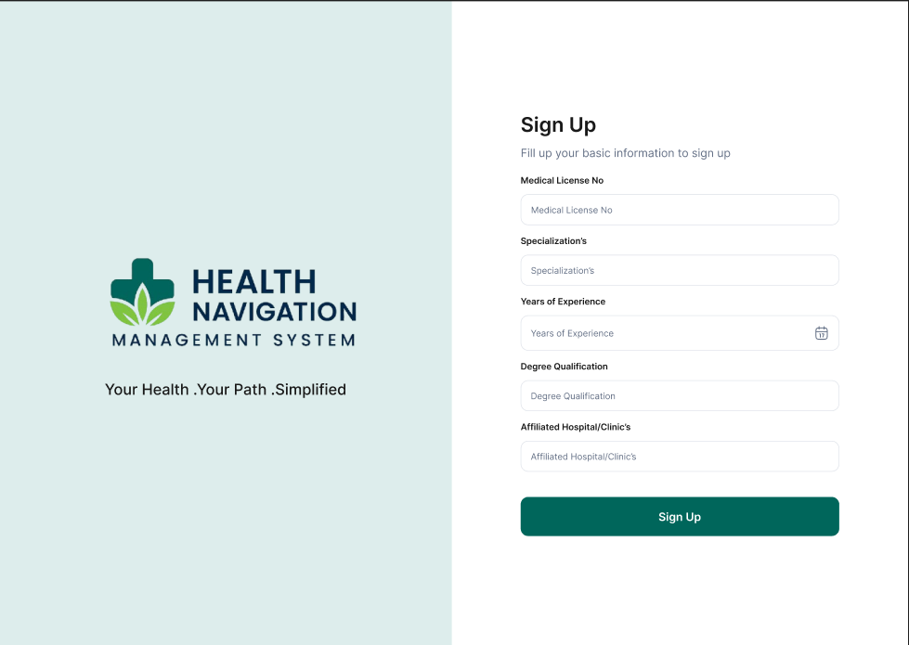

**Dr Dashboard**

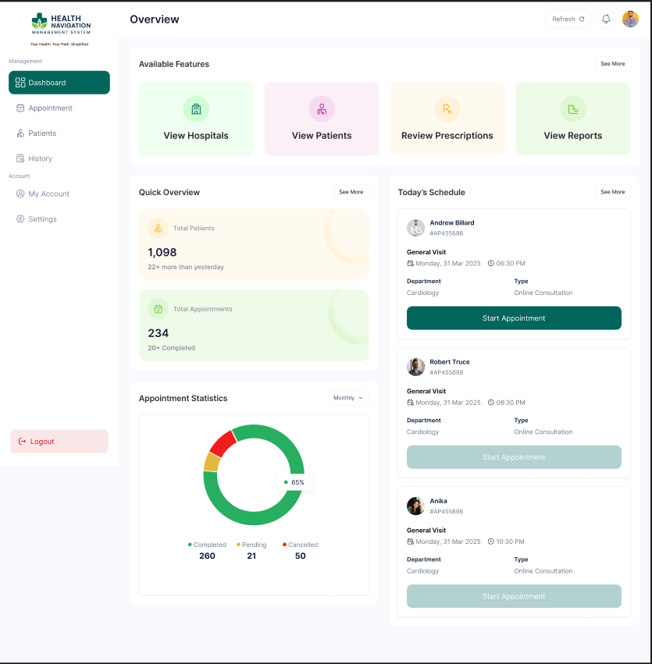

**Lab Sign up**

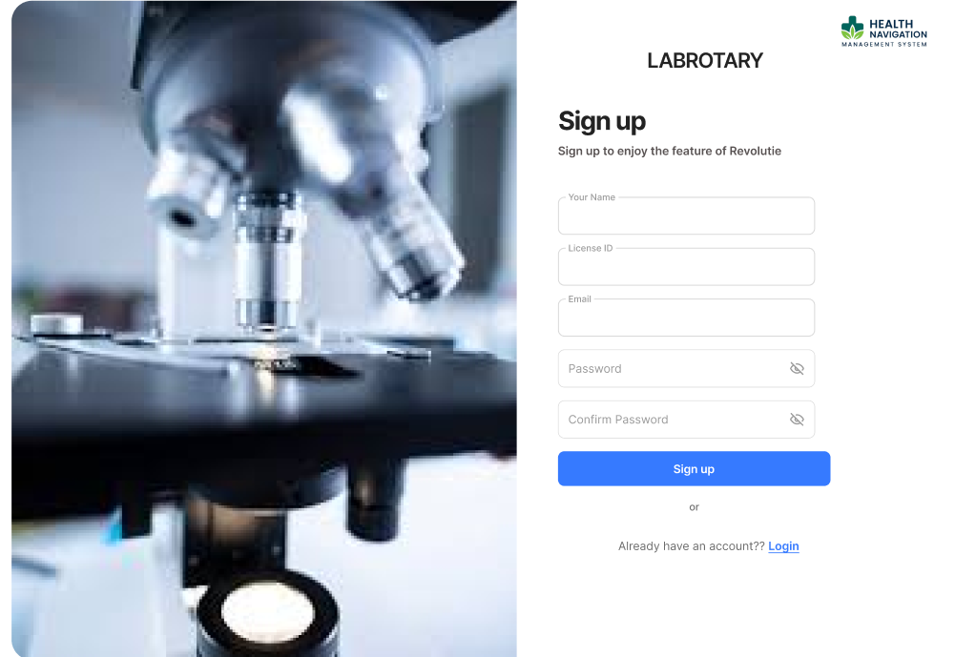

**Lab Signup  
  
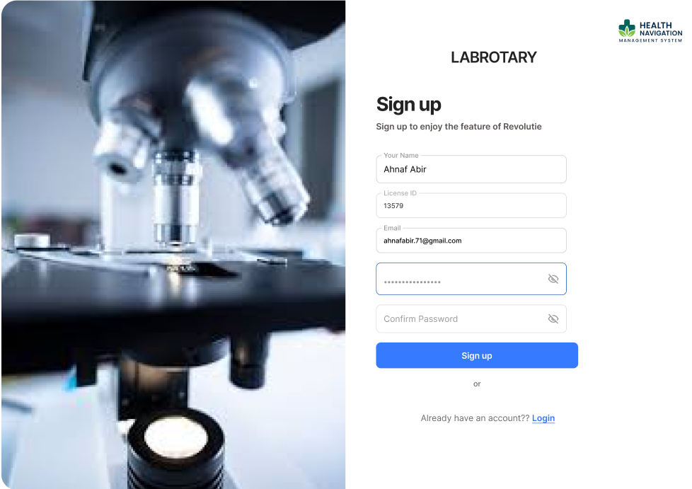**

**Lab Login**

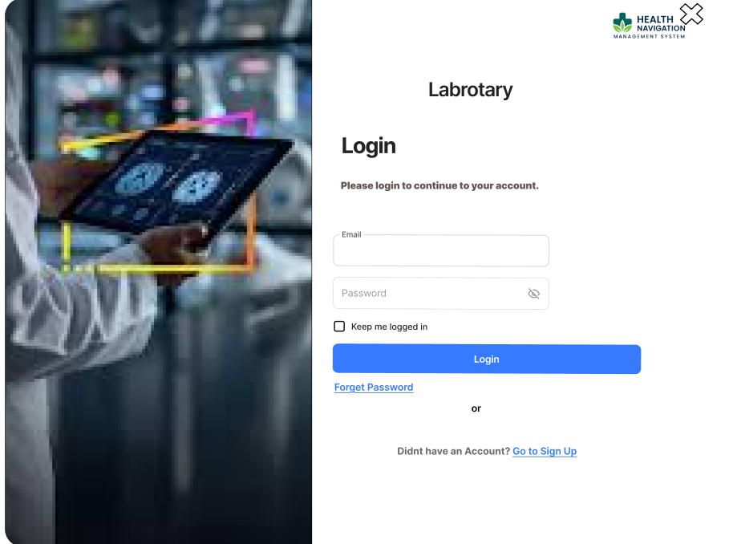

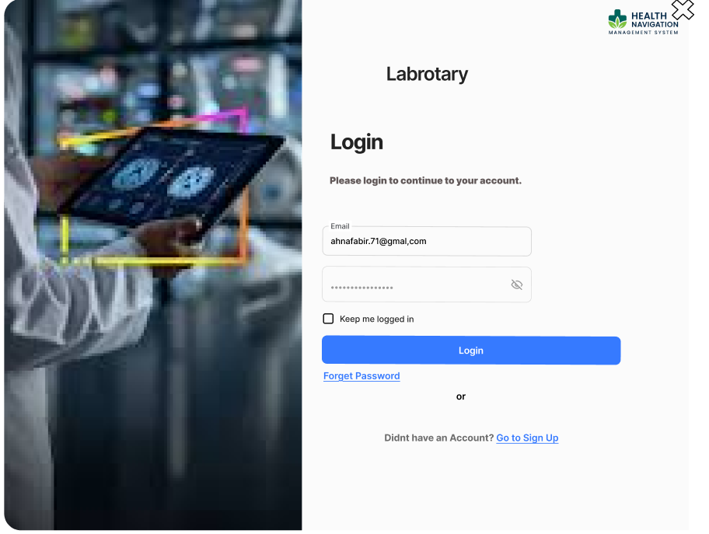**Lab Login**

# 5. SOFTWARE TESTING

|  |  |  |  |  |  |
| --- | --- | --- | --- | --- | --- |
| **Project Name : HRMS** | | | **Test Designed by: RIANA RAMZAN** | | |
| **Test Case: TC_01** | | | Test Designed Date:19-1-26 | | |
| **Test Priority: High** | | | Test Executed by:RIANA RAMZAN | | |
| **Module Name: Authentication** | | | Test Execution Date:20-1-26 | | |
| **Test Title: Verify login with valid email and password** | | | | | |
| **Description: Test the login functionality** | | | | | |
| **Precondition: User has a registered account** | | | | | |
| **Dependencies: Internet connection** | | | | | |
| **Test Steps** | **Test Data** | **Expected Results** | | **Actual Results** | **Status** |
| 1. Go to login Page 2. Enter email 3. Enter Password 4. Click Signin | Email:[user@mail.com](mailto:user@mail.com)  Password: **** | User is logged in successfully | | **As expected** | **Pass** |

|  |  |  |  |  |  |
| --- | --- | --- | --- | --- | --- |
| **Project Name : HRMS** | | | **Test Designed by: RIANA RAMZAN** | | |
| **Test Case: TC_02** | | | Test Designed Date: 19-1-26 | | |
| **Test Priority: High** | | | Test Executed by: **RIANA RAMZAN** | | |
| **Module Name: Authentication** | | | Test Execution Date: 20-1-26 | | |
| **Test Title: Login with invalid password** | | | | | |
| **Description: Verify error message appears** | | | | | |
| **Precondition: User is registered** | | | | | |
| **Dependencies: Internet connection** | | | | | |
| **Test Steps** | **Test Data** | **Expected Results** | | **Actual Results** | **Status** |
| 1. Go to login Page 2. Enter email 3. Enter Wrong Password 4. Click Signin | Email:[user@mail.com](mailto:user@mail.com)  Password: 12345 | Error message shown | | **As expected** | **Pass** |

|  |  |  |  |  |  |
| --- | --- | --- | --- | --- | --- |
| **Project Name : HRMS** | | | **Test Designed by: RIANA RAMZAN** | | |
| **Test Case: TC_03** | | | Test Designed Date: 19-1-26 | | |
| **Test Priority: High** | | | Test Executed by: **RIANA RAMZAN** | | |
| **Module Name: Authentication** | | | Test Execution Date: 20-1-26 | | |
| **Test Title: Login with empty fields** | | | | | |
| **Description: Validate input fields** | | | | | |
| **Precondition: None** | | | | | |
| **Dependencies: Internet connection** | | | | | |
| **Test Steps** | **Test Data** | **Expected Results** | | **Actual Results** | **Status** |
| 1. Go to login Page 2. Leave fields empty 3. Click login | None | **Validation message displayed** | | **As expected** | **Pass** |

|  |  |  |  |  |  |
| --- | --- | --- | --- | --- | --- |
| **Project Name : HRMS** | | | **Test Designed by: RIANA RAMZAN** | | |
| **Test Case: TC_04** | | | Test Designed Date: 19-1-26 | | |
| **Test Priority: High** | | | Test Executed by: **RIANA RAMZAN** | | |
| **Module Name: Registration** | | | Test Execution Date: 20-1-26 | | |
| **Test Title: Register doctor with valid data** | | | | | |
| **Description: Verify doctor registration** | | | | | |
| **Precondition: User not registered** | | | | | |
| **Dependencies: Internet connection** | | | | | |
| **Test Steps** | **Test Data** | **Expected Results** | | **Actual Results** | **Status** |
| 1. Go to Doctor Registration 2. Fill all required fields 3. Click Register | Name: Dr. Rahman  Email:[doctor@mail.com](mailto:doctor@mail.com)  Password: **** | **Registration successful** | | **As expected** | **FAILED** |

|  |  |  |  |  |  |
| --- | --- | --- | --- | --- | --- |
| **Project Name : HRMS** | | | **Test Designed by: RIANA RAMZAN** | | |
| **Test Case: TC_05** | | | Test Designed Date: 19-1-26 | | |
| **Test Priority: Medium** | | | Test Executed by: **RIANA RAMZAN** | | |
| **Module Name: Registration** | | | Test Execution Date: 20-1-26 | | |
| **Test Title: Register with existing email** | | | | | |
| **Description: Prevent duplicate registration** | | | | | |
| **Precondition: Email already registered** | | | | | |
| **Dependencies: Internet connection** | | | | | |
| **Test Steps** | **Test Data** | **Expected Results** | | **Actual Results** | **Status** |
| 1. Go to Registration page 2. Enter already registered email 3. Fill other required fields 4. Click Register | Email: user@gmail.com | **Error message shown** | | **As expected** | **Pass** |

|  |  |  |  |  |  |
| --- | --- | --- | --- | --- | --- |
| **Project Name : HRMS** | | | **Test Designed by: RAKIBUL ISLAM AKASH** | | |
| **Test Case: TC_06** | | | Test Designed Date: 19-1-26 | | |
| **Test Priority: High** | | | Test Executed by: **RAKIBUL ISLAM AKASH** | | |
| **Module Name: Forgot Password** | | | Test Execution Date: 20-1-26 | | |
| **Test Title: Forgot password with valid email** | | | | | |
| **Description: Verify reset link sent** | | | | | |
| **Precondition: User has a registered account** | | | | | |
| **Dependencies: Internet connection** | | | | | |
| **Test Steps** | **Test Data** | **Expected Results** | | **Actual Results** | **Status** |
| 1. Go to Forget Password 2. Enter registered email 3. Click Submit | Email:[user@mail.com](mailto:user@mail.com) | **Reset link sent to email** | | **As expected** | **Pass** |

|  |  |  |  |  |  |
| --- | --- | --- | --- | --- | --- |
| **Project Name : HRMS** | | | **Test Designed by: RAKIBUL ISLAM AKASH** | | |
| **Test Case: TC_07** | | | Test Designed Date: 19-1-26 | | |
| **Test Priority: Medium** | | | Test Executed by: **RAKIBUL ISLAM AKASH** | | |
| **Module Name: Forgot Password** | | | Test Execution Date: 20-1-26 | | |
| **Test Title: Forgot password with invalid email** | | | | | |
| **Description: Validate unknown email** | | | | | |
| **Precondition: User has a registered account** | | | | | |
| **Dependencies: Internet connection** | | | | | |
| **Test Steps** | **Test Data** | **Expected Results** | | **Actual Results** | **Status** |
| 1. Go to Forget Password 2. Enter registered email 3. Click Submit | Email:[qwez@mail.com](mailto:fake@mail.com) | **Email not found message** | | **As expected** | **Pass** |

|  |  |  |  |  |  |
| --- | --- | --- | --- | --- | --- |
| **Project Name : HRMS** | | | **Test Designed by: RAKIBUL ISLAM AKASH** | | |
| **Test Case: TC_08** | | | Test Designed Date: 19-1-26 | | |
| **Test Priority: High** | | | Test Executed by: **RAKIBUL ISLAM AKASH** | | |
| **Module Name: Password Reset** | | | Test Execution Date: 20-1-26 | | |
| **Test Title: Reset password with valid new password** | | | | | |
| **Description: Verify password update** | | | | | |
| **Precondition: User opened reset link** | | | | | |
| **Dependencies: Internet connection** | | | | | |
| **Test Steps** | **Test Data** | **Expected Results** | | **Actual Results** | **Status** |
| 1. Open reset password link 2. Enter new password 3. Confirm new password 4. Click Reset | Password: newpass123 | **Password updated successfully** | | **As expected** | **Pass** |

|  |  |  |  |  |  |
| --- | --- | --- | --- | --- | --- |
| **Project Name : HRMS** | | | **Test Designed by: RAKIBUL ISLAM AKASH** | | |
| **Test Case: TC_09** | | | Test Designed Date: 19-1-26 | | |
| **Test Priority: High** | | | Test Executed by: **RAKIBUL ISLAM AKASH** | | |
| **Module Name: Dashboard (Patient)** | | | Test Execution Date: 20-1-26 | | |
| **Test Title: Verify patient dashboard loads** | | | | | |
| **Description: Ensure dashboard opens correctly** | | | | | |
| **Precondition: User logged in** | | | | | |
| **Dependencies: Internet connection** | | | | | |
| **Test Steps** | **Test Data** | **Expected Results** | | **Actual Results** | **Status** |
| 1. Login as patient 2. Observe dashboard elements | None | **Dashboard displayed** | | **As expected** | **failed** |

|  |  |  |  |  |  |
| --- | --- | --- | --- | --- | --- |
| **Project Name : HRMS** | | | **Test Designed by: RAKIBUL ISLAM AKASH** | | |
| **Test Case: TC_10** | | | Test Designed Date:19-1-26 | | |
| **Test Priority: High** | | | Test Executed by: **RAKIBUL ISLAM AKASH** | | |
| **Module Name: Dashboard (Admin)** | | | Test Execution Date:20-1-26 | | |
| **Test Title: Verify admin dashboard statistics** | | | | | |
| **Description: Check admin overview data** | | | | | |
| **Precondition: Admin logged in** | | | | | |
| **Dependencies: Internet connection** | | | | | |
| **Test Steps** | **Test Data** | **Expected Results** | | **Actual Results** | **Status** |
| 1. Login as admin 2. Navigate to Admin Dashboard 3. Check widgets and statistics | None | **All widgets load correctly** | | **As expected** | **Pass** |

|  |  |  |  |  |  |
| --- | --- | --- | --- | --- | --- |
| **Project Name : HRMS** | | | **Test Designed by: MD.RAKIB HOSSAIN** | | |
| **Test Case: TC_11** | | | Test Designed Date:19-1-26 | | |
| **Test Priority: Medium** | | | Test Executed by: **MD.RAKIB HOSSAIN** | | |
| **Module Name: Profile** | | | Test Execution Date:20-1-26 | | |
| **Test Title: Update user profile** | | | | | |
| **Description: Verify profile update functionality** | | | | | |
| **Precondition: User logged in** | | | | | |
| **Dependencies: Internet connection** | | | | | |
| **Test Steps** | **Test Data** | **Expected Results** | | **Actual Results** | **Status** |
| 1. Login to system 2. Go to Profile page 3. Edit personal information 4. Click Save | None | **Profile updated successfully** | | **As expected** | **Pass** |

|  |  |  |  |  |  |
| --- | --- | --- | --- | --- | --- |
| **Project Name : HRMS** | | | **Test Designed by: MD.RAKIB HOSSAIN** | | |
| **Test Case: TC_12** | | | Test Designed Date:19-1-26 | | |
| **Test Priority: Low** | | | Test Executed by: **MD.RAKIB HOSSAIN** | | |
| **Module Name: Profile** | | | Test Execution Date:20-1-26 | | |
| **Test Title: Upload profile picture** | | | | | |
| **Description: Verify image upload** | | | | | |
| **Precondition: User has a registered account** | | | | | |
| **Dependencies: Internet connection** | | | | | |
| **Test Steps** | **Test Data** | **Expected Results** | | **Actual Results** | **Status** |
| 1. Login to system 2. Go to Profile 3. Click Upload Photo 4. Select image 5. Click Save | None | **Image uploaded successfully** | | **As expected** | **Pass** |

|  |  |  |  |  |  |
| --- | --- | --- | --- | --- | --- |
| **Project Name : HRMS** | | | **Test Designed by:MD.RAKIB HOSSAIN** | | |
| **Test Case: TC_13** | | | Test Designed Date:19-1-26 | | |
| **Test Priority: Medium** | | | Test Executed by: **MD.RAKIB HOSSAIN** | | |
| **Module Name: Navigation** | | | Test Execution Date:20-1-26 | | |
| **Test Title: Verify sidebar navigation** | | | | | |
| **Description: Ensure menu redirects correctly** | | | | | |
| **Precondition: User has a registered account** | | | | | |
| **Dependencies: Internet connection** | | | | | |
| **Test Steps** | **Test Data** | **Expected Results** | | **Actual Results** | **Status** |
| 1. Login to system 2. Click Dashboard 3. Click Profile 4. Click Logout | None | **Pages open correctly** | | **As expected** | **Pass** |

|  |  |  |  |  |  |
| --- | --- | --- | --- | --- | --- |
| **Project Name : HRMS** | | | **Test Designed by: MD.RAKIB HOSSAIN** | | |
| **Test Case: TC_14** | | | Test Designed Date:19-1-26 | | |
| **Test Priority: High** | | | Test Executed by: **MD.RAKIB HOSSAIN** | | |
| **Module Name: Logout** | | | Test Execution Date:20-1-26 | | |
| **Test Title: Verify logout functionality** | | | | | |
| **Description: Ensure session ends** | | | | | |
| **Precondition: User has a registered account** | | | | | |
| **Dependencies: Internet connection** | | | | | |
| **Test Steps** | **Test Data** | **Expected Results** | | **Actual Results** | **Status** |
| 1. Login to system 2. Click Logout button | None | **User redirected to login page** | | **As expected** | **Pass** |

|  |  |  |  |  |  |
| --- | --- | --- | --- | --- | --- |
| **Project Name : HRMS** | | | **Test Designed by: MD.RAKIB HOSSAIN** | | |
| **Test Case: TC_15** | | | Test Designed Date:19-1-26 | | |
| **Test Priority: High** | | | Test Executed by: **MD.RAKIB HOSSAIN** | | |
| **Module Name: Security** | | | Test Execution Date:20-1-26 | | |
| **Test Title: Access dashboard without login** | | | | | |
| **Description: Prevent unauthorized access** | | | | | |
| **Precondition: None** | | | | | |
| **Dependencies: Internet connection** | | | | | |
| **Test Steps** | **Test Data** | **Expected Results** | | **Actual Results** | **Status** |
| 1. Open browser 2. Enter dashboard URL directly | None | **Redirected to login page** | | **As expected** | **FAILED** |

|  |  |  |  |  |  |
| --- | --- | --- | --- | --- | --- |
| **Project Name: Health Navigation & Management System** | | | | **Test Designed by:** Abir | |
| **Test Case ID: Lab 1** | | | | Test Designed date: 15.01.26 | |
| **Test Priority: Medium** | | | | Test Executed by: Abir | |
| **Module Name: Laboratory Registration** | | | | Test Execution date: 16.0126 | |
| **Test Title: Verify registration with valid information** | | | |  | |
| **Description: Test the laboratory registration page** | | | |  | |
| **Precondition: User is not registered** | | | | | |
| **Dependencies: None** | | | | | |
| **Test Steps** | **Test Data** | **Expected Results** | **Actual Results** | | **Status(Fail or Pass)** |
| 1. Go to registration page 2. Enter License Number 3. Enter valid details 4. Enter password 5. Confirm Pass 6. Click Sign Up | |  |  | | --- | --- | | Name: Ahnaf Abir  Licence Id:13579  Email: ahnafabir@email.com  Password: 12345 |  |   Confirm Pass:12345 | |  | | --- | |  |  |  | | --- | | User account should be created | | As expected | | Pass |

|  |  |  |  |  |  |
| --- | --- | --- | --- | --- | --- |
| **Project Name: Health Navigation & Management System** | | | | **Test Designed by:** Abir | |
| **Test Case ID: Lab 2** | | | | Test Designed date: 15.01.26 | |
| **Test Priority: Medium** | | | | Test Executed by: Abir | |
| **Module Name: Laboratory Login** | | | | Test Execution date: 16.0126 | |
| **Test Title: Verify login with valid username and password** | | | |  | |
| **Description: Test the login page** | | | |  | |
| **Precondition: User is registered** | | | | | |
| **Dependencies: None** | | | | | |
| **Test Steps** | **Test Data** | **Expected Results** | **Actual Results** | | **Status(Fail or Pass)** |
| 1. Go to login page 2. Enter email 3. Enter password 4. 4. Click Login | Email: ahnafabir.71@gmail.com   |  |  | | --- | --- | | Password: 12345 |  | | User should log in successfully | As expected | | Pass |

|  |  |  |  |  |  |
| --- | --- | --- | --- | --- | --- |
| **Project Name: Health Navigation & Management System** | | | | **Test Designed by:** Abir | |
| **Test Case ID: Lab 3** | | | | Test Designed date: 15.01.26 | |
| **Test Priority: Medium** | | | | Test Executed by: Abir | |
| **Module Name: Forgot Password** | | | | Test Execution date: 16.0126 | |
| **Test Title: Verify forgot password with invalid email** | | | |  | |
| **Description: Test the forgot password page with incorrect email** | | | |  | |
| **Precondition: User account exists** | | | | | |
| **Dependencies: None** | | | | | |
| **Test Steps** | **Test Data** | **Expected Results** | **Actual Results** | | **Status(Fail or Pass)** |
| 1. 1. Go to forgot password page 2. 2. Enter email 3. Click submit | |  |  | | --- | --- | | Email: wrongtest.com |  | | |  | | --- | |  |  |  | | --- | | System should show error message | | Error message not shown | | fail |

|  |  |  |  |  |  |
| --- | --- | --- | --- | --- | --- |
| **Project Name: Health Navigation & Management System** | | | | **Test Designed by:** Abir | |
| **Test Case ID: Lab 4** | | | | Test Designed date: 15.01.26 | |
| **Test Priority: Medium** | | | | Test Executed by: Abir | |
| **Module Name: Laboratory Registration** | | | | Test Execution date: 16.0126 | |
| **Test Title: Verify registration with empty required fields** | | | |  | |
| **Description: Validate required field enforcement in registration** | | | |  | |
| **Precondition: User is on registration page** | | | | | |
| **Dependencies: None** | | | | | |
| **Test Steps** | **Test Data** | **Expected Results** | **Actual Results** | | **Status(Fail or Pass)** |
| 1. Open registration page 2. Leave email empty 3. Click submit | |  |  | | --- | --- | | Name: (empty)  Email: (empty) |  | | |  | | --- | |  |  |  |  |  | | --- | --- | --- | | |  | | --- | |  |  |  | | --- | | System should show required field error | | | Error shown | | Pass |

|  |  |  |  |  |  |
| --- | --- | --- | --- | --- | --- |
| **Project Name: Health Navigation & Management System** | | | | **Test Designed by:** Abir | |
| **Test Case ID: Lab 5** | | | | Test Designed date: 15.01.26 | |
| **Test Priority: Medium** | | | | Test Executed by: Abir | |
| **Module Name: Laboratory Login** | | | | Test Execution date: 16.0126 | |
| **Test Title: Verify login with invalid email format** | | | |  | |
| **Description: Validate email format in login** | | | |  | |
| **Precondition: User is on login page** | | | | | |
| **Dependencies: None** | | | | | |
| **Test Steps** | **Test Data** | **Expected Results** | **Actual Results** | | **Status(Fail or Pass)** |
| 1. Open login page  2.Enter invalid email  3.Click submit | |  |  |  |  | | --- | --- | --- | --- | | Email: ahnafabir.com   |  | | --- | |  |  |  | | --- | | Password: 12345 | |  | | |  | | --- | |  |  |  |  |  | | --- | --- | --- | | |  | | --- | |  |  |  | | --- | | System should show format error | | | Error shown | | |  | | --- | |  |  |  | | --- | | Pass | |